List of interviewers for conducting household Survey on information and Communications Technology Use and Travel Expenditures
Operating period from January 23 to February 12, 2025

Last nama, first name and pattonymic of the interviewer |  | Surveyed locality
Sizova Ekaterina Nikolaevna |  | c.а. Pavlodara
Asanova Rezida Fasikhovna |  | c.а. Pavlodara
Savelyeva Albina Andreevna |  | c.а. Pavlodara
Volkova Nadezhda Sergeevna |  | c.а. Pavlodara
Kushpecova Gaukhar Sabitovna |  | c.а. Pavlodara
Baybusunova  Gulnar Abdykarimovna |  | c.а. Aksu
Apergenova Zhumagul Ziyadanovna | 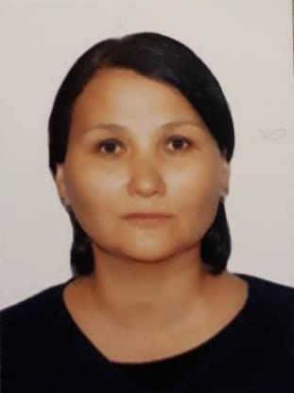 | c.а. Ekibastuz
Katarova Diana Tanatarovna |  | c.а. Ekibastuz
Abdygalieva  Nargul Mubarakovna | 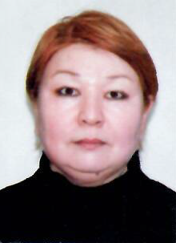 | Aktogay district
Ilyasheva Kuralai Kuandykovna |  | Bayanaul district
Komnik  Victoria Sergeevna |  | Zhelezinsky district
Idrisova  Nazgul Zhanatalyapovna |  | Irtysh district
Urtakova  Marina Temirzhanovna |  | Terenkol district
Baitleuova  Zhanat | 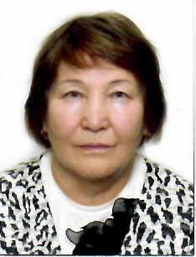 | Akkuly district
Abdykarimova Aliya Ibragimovna |  | Maysky district
Nadezhda Alexandrovna Bobrova |  | Pavlodar district
Donets  Zarina Ablaikanovna |  | Uspensky district
Kasyanenko Elena Valerievna |  | Shcherbakty district

